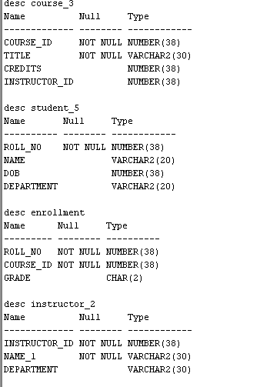
Course_3

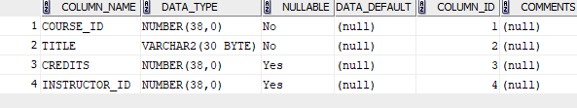
Enrollment

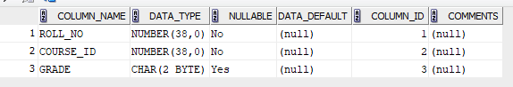

Instructor
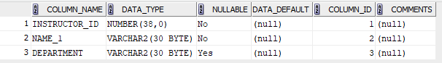

student
